CPR Broker
PART standard
Core Engine
Design specification

Magenta Aps
Contents
1 Overview 3
2 PART Operations 4
2.1 Create 4
2.2 Import 5
2.3 Read 6
2.4 Edit 7
2.5 Delete 8
2.6 Deactivate 8
2.7 Search 9
2.8 List 9

Overview
This part of the project is about a generic implementation of the PART standard. Individual implementations of dependent standards can be built on top of this part.
The following diagram shows an overview of this part.

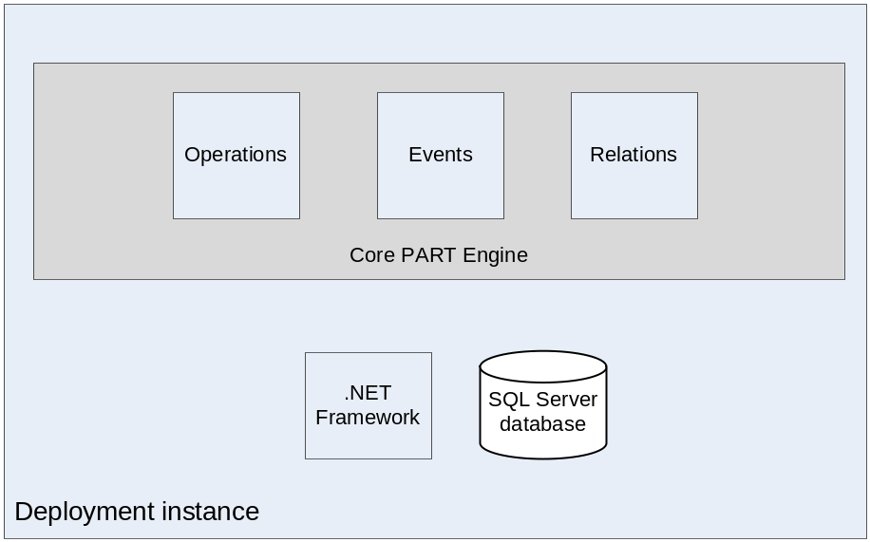

PART Operations
In this section, there is a description of each operation of the operations required by the standard. This text will focus on the technical implementation and the used algorithm rather than the requirements which are already specified by the standard.
A common property of all operations is that operations run as a transaction. This means that it is either run fully or rejected fully.

Create
Creates a new object with a new UUID. Object data is copied from the request to the database. Object specific fields are handles by the appropriate implementation.
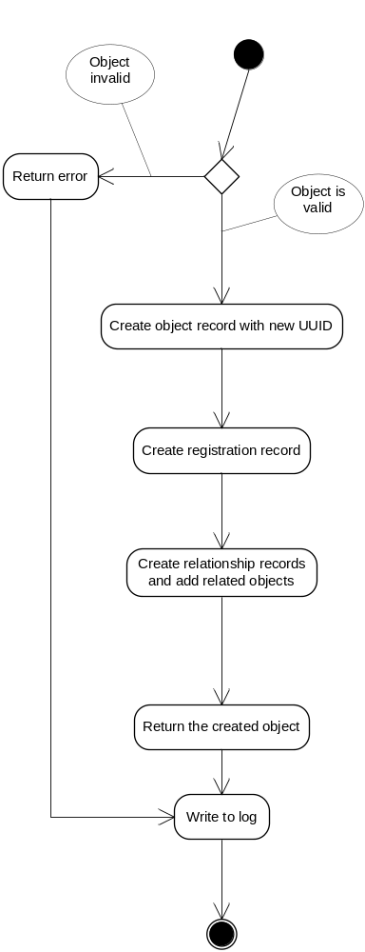

Import
This process is very similar to Create, but the object ID here is taken from the input object. It is validated that the object ID is not in the database.
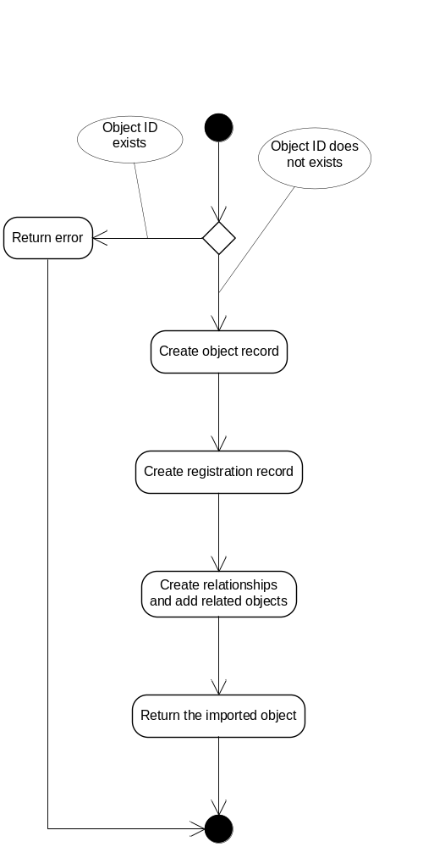

Read
Reads an object from the database (if found). It can also get a historical view of the object (if possible).
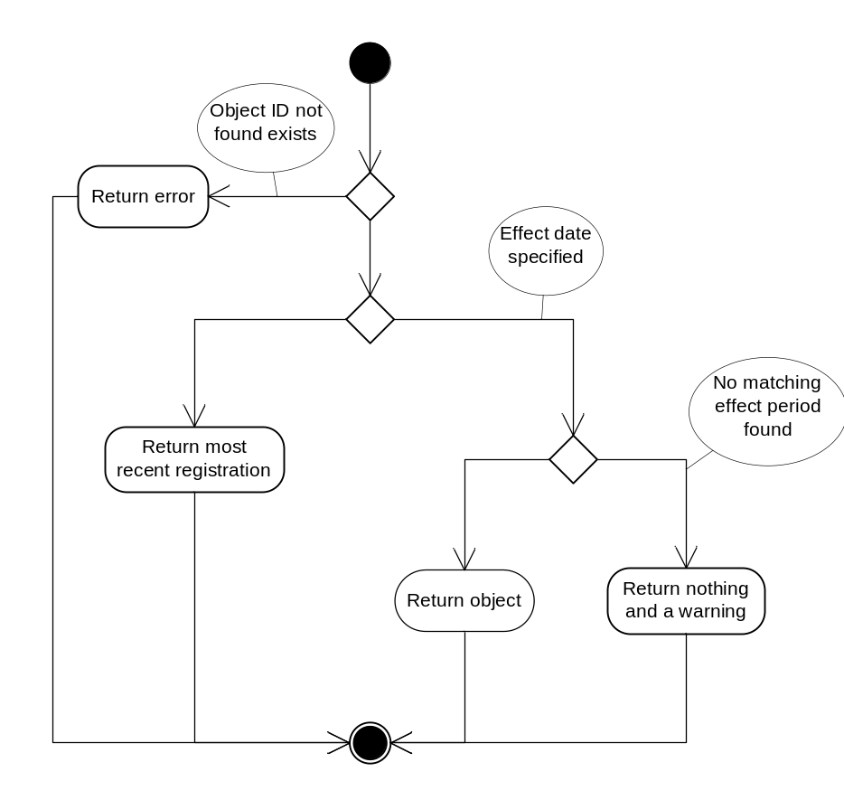

Edit
Updates an object with a new (or old) version. The new object is verified to avoid conflicting effect periods.
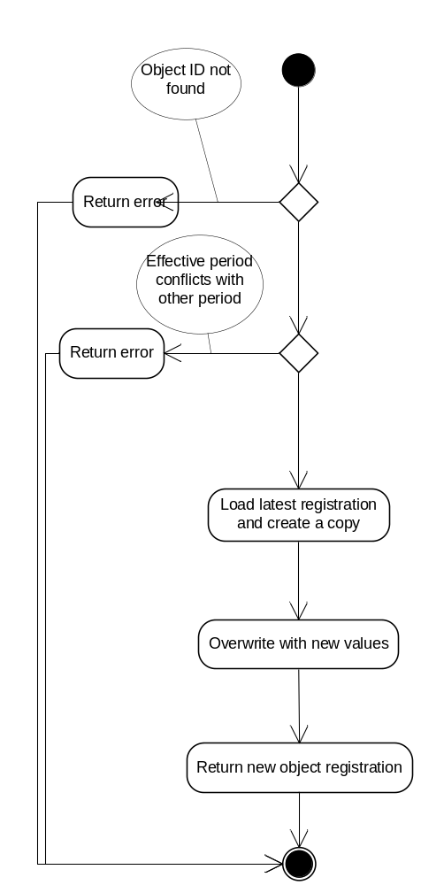

Delete
Marks an object as deleted.
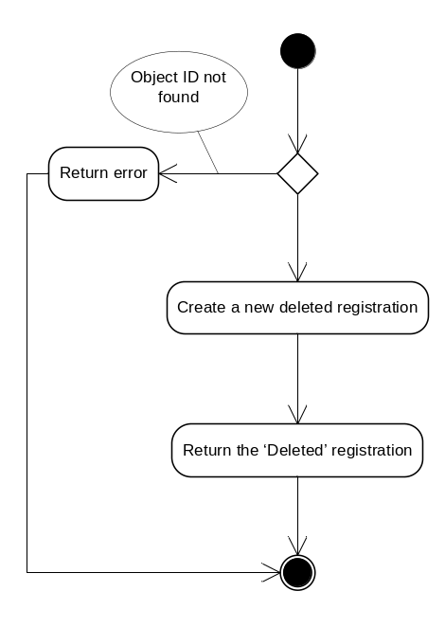

Deactivate
Marks an object as inactive.
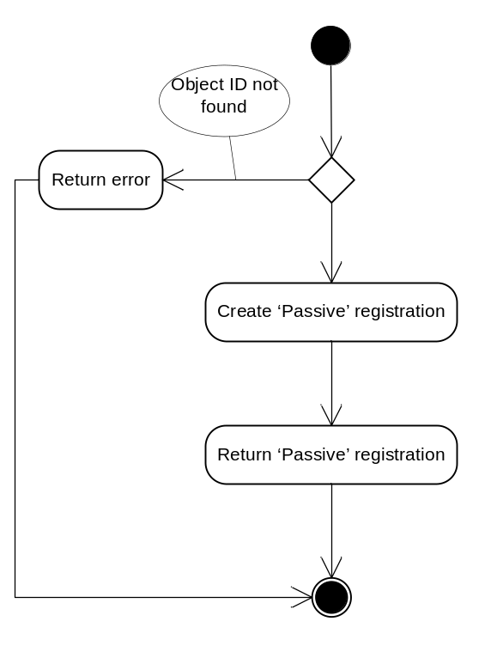

Search
Gets a list of object ID’s based on some search criteria.
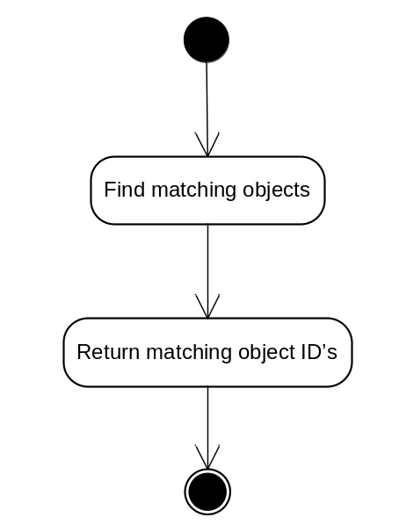

List
Similar to Read, it gets the objects based on their ID’s. The difference is that this one accepts a list of ID’s rather than a single ID.
